The Self – Care Wheel
Within each of the six dimensions the Self -Care wheels suggests broad ranging self care activities. Individuals can add their own to the list. One activity can nuture several different dimensions.
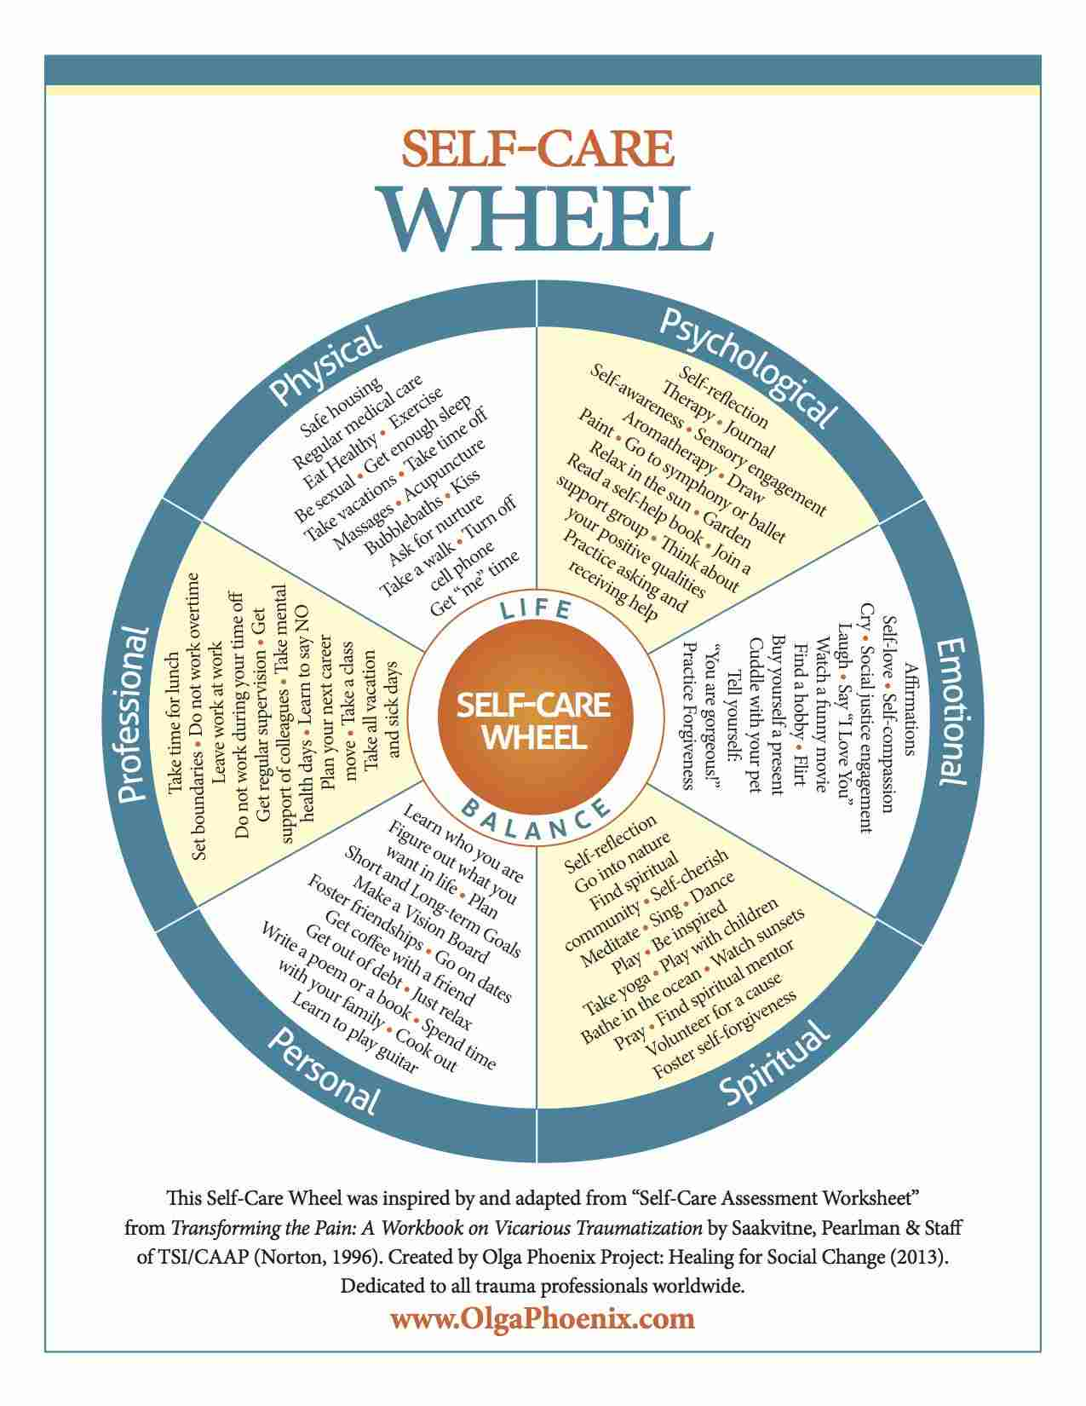
The assessment tool can be used to evaluate where you are. The idea is to rate yourself in each dimension with 10 signifying we are spending a lot of time and energy in this area of our lives and are completely satisfied and the self care activities we are doing are working well for us.
Reflect on why some areas score highly, what specific strategies have supported this, acknowledge life events can mean low scores in some areas are outside our control.
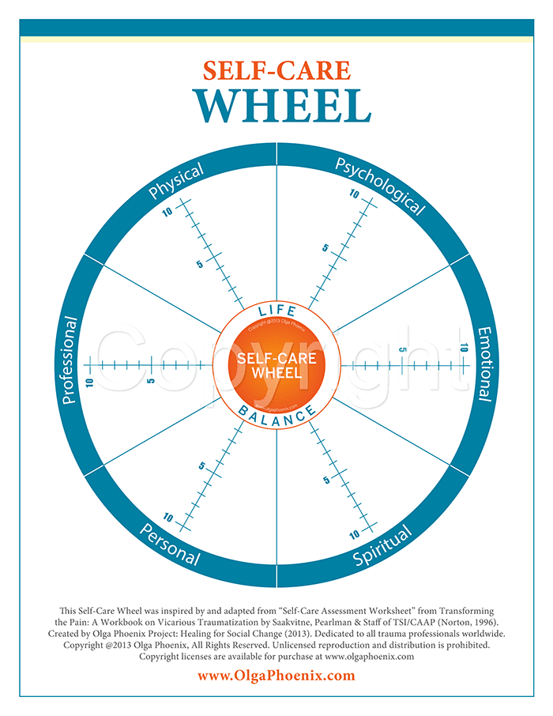

Create your own self care wheel, identifying the activities which nourish and sustain you.
