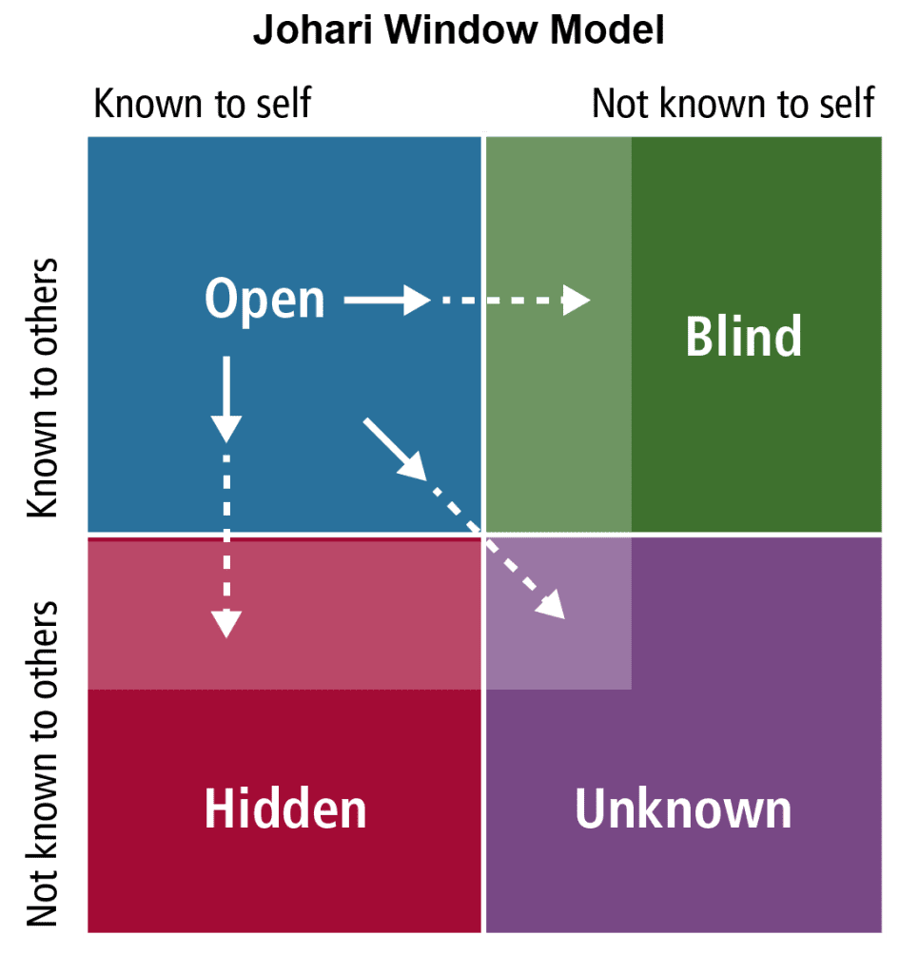
Developed in 1955 by Joseph Luft & Harry Ingham. The model can be used for improving self awareness, personal development, communication.
Open: Information about you that both you and others know.
Blind: Information about you that you don’t know but others do
Hidden: Information about you that you know but others don’t
Unknown self: Information about you that neither you nor others know.
The aim is to increase the open area by creating safety which encourages self disclsure, providing sensitive feedback and creating opportunities to develop new competences.

